A Project Synopsis on

**Smart Traffic Signal System with Dynamic Vehicle Detection**

**COMPUTER SCIENCE AND ENGINEERING**

**(DATA SCIENCE)**

**BY**

**Mr. Buddhiraj Ganesh Bhosle (03)**

**Mr. Rajratn Ajit Ghatage (12)**

**Mr. Ganesh Ashok Ingale (19)**

**Mr. Kapil Jayram Kakade (21)**

Under the guidance of

**Prof. Supriya Laykar**

Assistant Professor



**Department of Computer Science and Engineering**

**(Data Science)**

**Dr. D.Y. Patil Pratishthan's College of Engineering,**

**Kalamba Ring Road, Salokhenagar Kolhapur-416007**

**Index**

|  |  |  |
| --- | --- | --- |
| Sr. No. | Contents | Page No. |
| 1 | Introduction | 3 |
| 2 | Literature Survey / Review of Existing System | 4 |
| 3 | Problem Specification / Proposed System | 5 |
| 4 | Hardware / Software Requirements | 7 |
| 5 | System Design and Implementation | 9 |
| 6 | Conclusion | 10 |
| 7 | References / Bibliography | 11 |

**Introduction**

Traffic congestion is one of the most pressing issues in urban areas worldwide, causing delays, fuel wastage, and increased pollution. Traditional traffic signal systems often operate on fixed timers, irrespective of the actual traffic density. This static approach leads to inefficiencies, as some lanes experience prolonged waits while others remain underutilized. To address these challenges, intelligent and adaptive systems have become essential for modern urban planning.

The Smart Traffic Signal System is designed to dynamically adjust signal timings based on real-time vehicle detection and traffic density. By leveraging artificial intelligence (AI) technologies such as YOLOv5 for vehicle detection and utilizing Python's Pygame for visualization, this project aims to create a responsive and efficient traffic management solution. The system detects vehicles entering each lane, calculates signal timings proportionally based on vehicle count, and displays the results in an interactive simulation.

This adaptive approach not only reduces traffic congestion but also enhances the overall experience for commuters by minimizing idle time at signals. Furthermore, it optimizes traffic flow, contributing to environmental sustainability by reducing vehicle emissions. The project serves as a stepping stone toward smarter cities, offering scalable and innovative solutions for efficient traffic management in the future.

**Literature Survey / Review of Existing Systems**

Traffic management has traditionally relied on fixed-timer systems, where traffic signals operate on predefined intervals regardless of the actual density of vehicles. While these systems are simple and cost-effective, they are inefficient in managing the dynamic flow of traffic, often leading to congestion and frustration during peak hours.

To address these challenges, modern advancements have introduced semi-automated and fully automated systems. Below is a review of such existing solutions and their limitations:

1. Traditional Fixed-Timer Systems

Fixed-timer systems operate on set durations for green, yellow, and red lights without considering real-time traffic conditions. These systems fail to adapt to varying traffic densities, resulting in wasted time and increased fuel consumption.

Limitations:

1. Increased pollution due to prolonged idling.
2. Inefficient use of road space
3. Inflexibility during peak and off-peak hours

2. Adaptive Signal Control Systems

Adaptive systems aim to address the inefficiencies of fixed timers by incorporating sensor data to monitor traffic flow. These systems use technologies like inductive loop detectors and infrared sensors to adjust signal timings dynamically.

Limitations:

1. Limited accuracy in detecting vehicle types and numbers.
2. High installation and maintenance costs for sensor-based setups.
3. Sensor malfunctions can lead to inaccurate data.

3. AI-Powered Traffic Management Systems

Some systems integrate machine learning algorithms for traffic prediction and optimization. These systems can analyze historical data and patterns to improve signal timings. Examples include AI-based traffic prediction models and simulations.

Limitations:

1. Complexity in implementation and need for high computational power.
2. Reliance on historical data may not account for unexpected traffic events.

**Problem Specification/Proposed System**

Problem Specification :-

Traffic congestion is a significant challenge in urban areas, caused by rapid urbanization, increasing vehicle numbers, and inefficient traffic management systems. Existing traffic signal systems often operate on static timers that are unable to adapt to fluctuating vehicle densities. This leads to:

* Prolonged waiting times for commuters.
* Increased fuel consumption and emissions due to idling vehicles.
* Inefficient utilization of road capacity during off-peak hours.

While some adaptive systems exist, they rely on hardware-heavy solutions like sensors, which are expensive to install and maintain. Additionally, these systems lack robust integration of AI-based detection models and fail to provide user-friendly, real-time monitoring tools.

Proposed System :-

The Smart Traffic SignalSystem is designed to solve these inefficiencies using an AI-powered, cost-effective, and scalable approach. The proposed system incorporates the following modules:

1. Vehicle Detection and Counting Module
   * Uses YOLOv5, a deep learning model, to accurately detect and count vehicles in real time.
   * Processes image/video inputs from cameras (files or webcams) to identify vehicle classes such as cars, buses, motorcycles, and trucks.
   * Eliminates the need for physical sensors by leveraging AI-based image processing
2. Dynamic Signal Timing Module
   * Calculates green light durations based on real-time vehicle density in each lane.
   * Ensures equitable distribution of time across all directions to optimize traffic flow.
   * Adapts to sudden changes in traffic patterns, improving overall system efficiency.
3. Visualization and Simulation Module
   * Utilizes Pygame to simulate a virtual intersection with interactive visuals of traffic lights, lanes, and moving vehicles.
   * Displays signal timers, vehicle counts, and the state of each lane dynamically, providing an intuitive and user-friendly interface.
4. Input Options
   * Supports file-based inputs: Users can upload images from local storage for vehicle detection.
5. Modular and Scalable Design
   * The system can be scaled to manage multiple intersections in a city.
   * Designed to integrate with cloud-based storage for centralized data management and real-time analytics.

**Hardware / Software requirements**

### **Hardware Requirements :-**

1. **Cameras/Photos**
   * **High-Resolution Cameras**: Essential for capturing detailed images and videos of vehicles for accurate detection and counting.
   * **Photos**: Used for giving input for system.
   * **Monitors:** For displaying the simulation interface and visualizing traffic signal activity.
2. **System Requirements**
   * **Processor**: A powerful processor (e.g., Intel i5/i7 or AMD Ryzen 5/7) to handle real-time image processing and simulation.
   * **RAM**: At least 8 GB (16 GB recommended) to run YOLOv5, Python libraries, and Pygame simulation smoothly.
   * **Storage**: SSD (Solid State Drive) for faster loading of software and storing input/output data.
3. **Networking Equipment**
   * Routers and switches for connecting cameras and systems if deployed across multiple intersections.

### **Software Requirements :-**

1. **Operating System**
   * Windows 10 or later, Linux (Ubuntu, CentOS), or macOS for compatibility with Python and YOLOv5.
2. **Programming Languages**
   * **Python**: Primary language for developing modules like vehicle detection, signal timing calculation, and simulation.
3. **Libraries and Frameworks**
   * **YOLOv5 (Torch Hub)**: For real-time vehicle detection and counting.
   * **OpenCV**: For image processing and converting images for model input.
   * **Pygame**: For creating the simulation interface and visualizing traffic signals and vehicles.
   * **Tkinter**: For the graphical file dialog interface (image input).
4. **Development Environment**
   * **Code Editor**: PyCharm, Visual Studio Code, or any preferred IDE for Python development.
   * **Version Control**: Git for code collaboration and versioning.
5. **Additional Tools**
   * **Machine Learning Support**: PyTorch for handling YOLOv5 detection and computations.
   * **Visualization Tools**: Libraries like Matplotlib or Plotly for optional data visualization beyond Pygame.
6. **Optional Hosting Platforms**
   * Cloud services like AWS or Azure for scalable deployment in real-world intersections.

Here is a detailed **System Design and Implementation** section tailored to your **Smart Traffic Signal System** project:

### ****System Design****

#### **Data Flow Diagram (DFD)**

The system can be explained using the following levels of DFDs:

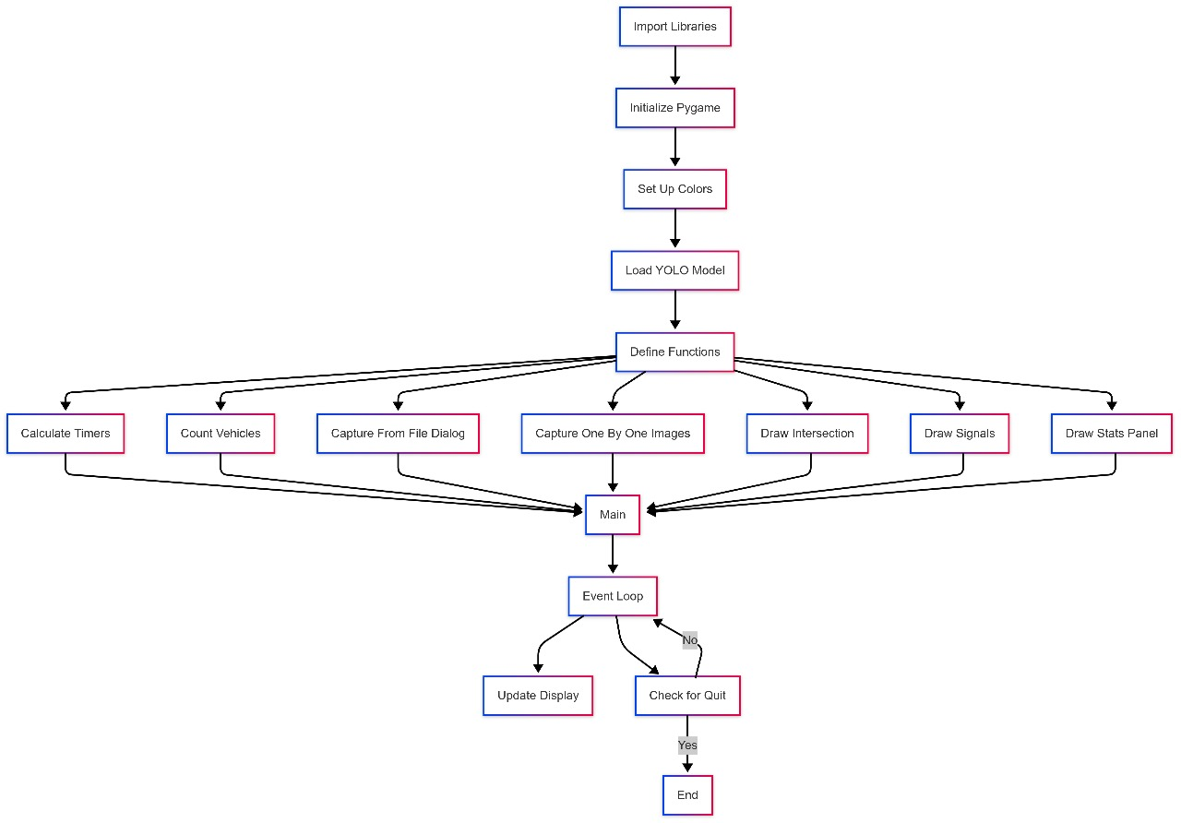

### ****Implementation****

#### **Modules and Components**

1. **Vehicle Detection Module**:
   * **Input**: Images or live video feed.
   * **Process**: YOLOv5 detects vehicles and counts them.
   * **Output**: A numerical count of vehicles per lane.
2. **Timer Calculation Module**:
   * **Input**: Vehicle counts for each lane.
   * **Process**: Compute green light durations proportionally.
   * **Output**: Timers for each signal.
3. **Visualization Module**:
   * **Input**: Signal and timer data.
   * **Process**: Simulate the intersection with vehicles and signals using Pygame.
   * **Output**: Graphical representation of the traffic intersection.
4. **User Interaction Module**:
   * **Input**: File dialog or webcam selection by the user.
   * **Process**: Allows user to provide traffic input.
   * **Output**: Signals the detection and simulation modules.

#### **Algorithms**

1. **Vehicle Detection**:
   * Convert image to RGB.
   * Feed into YOLOv5 for detection.
   * Filter detections by vehicle classes (car, bus, truck, etc.).
   * Count and output detected vehicles.
2. **Dynamic Timer Calculation**:
   * Aggregate vehicle counts across lanes.
   * Calculate proportional timings: $$\text{Timer} = \text{max}(1, \text{(vehicle count/total vehicles)} \times 60)$$.
   * Assign timers to signals.
3. **Simulation**:
   * Draw intersection and lanes.
   * Visualize vehicles as moving rectangles and signals as circles.
   * Update timers dynamically based on real-time input.

* **Framework**: Python for all implementations.
* **Libraries**:
  + Pygame: For simulation interface.
  + OpenCV: For pre-processing images for YOLOv5.
  + Torch: For running the YOLOv5 detection model.🚦✨

**Conclusion**

The Smart Traffic Signal System represents a significant step forward in addressing traffic congestion and inefficiencies in urban areas. By leveraging cutting-edge AI technology, such as YOLOv5 for vehicle detection and real-time data processing, the system ensures dynamic adjustment of signal timings based on traffic density. This intelligent approach reduces idle times at intersections, enhances traffic flow, and minimizes fuel wastage and environmental impact.

The integration of a Pygame-based visualization provides an interactive and intuitive platform for testing and monitoring the system, making it user-friendly and effective for stakeholders. The modular design of the system ensures scalability, making it adaptable for deployment across multiple intersections and urban areas, contributing to smart city initiatives.

In conclusion, the Smart Traffic Signal System offers an innovative, cost-efficient, and practical solution to modern traffic management challenges. Its ability to optimize signal timings dynamically not only improves commuter experience but also enhances urban mobility and environmental sustainability. As cities grow and traffic patterns become increasingly complex, this project lays a solid foundation for intelligent automation in traffic management, paving the way for smarter and more efficient cities.

### ****References / Bibliography****

1. **YOLOv5 Documentation**Ultralytics. "YOLOv5: Real-Time Object Detection". Accessed online at [https://github.com/ultralytics/yolov5].
2. **Pygame Documentation**  
   Pygame. "Introduction to Pygame". Accessed online at [https://www.pygame.org/docs].
3. **OpenCV Documentation**  
   OpenCV. "Computer Vision Library for Python". Accessed online at [https://docs.opencv.org].
4. **Deep Learning Concepts**  
   Goodfellow, Ian, et al. Deep Learning. MIT Press, 2016. ISBN: 9780262035613.
5. **Traffic Signal Optimization**  
   Kadiyali, L.R. Traffic Engineering and Transport Planning. Khanna Publishers, 2014.
6. **Urban Traffic Management Systems**  
   Ceder, Avishai. Public Transit Planning and Operation: Modeling, Practice and Behavior. CRC Press, 2007.
7. **AI Applications in Traffic Management**Rong, Xiaoming, et al. "License Plate Recognition System Based on Deep Learning". IEEE Access 8 (2020): 181601-181609.
8. **Generative AI in Simulation Design**Wang, Hongyu. "AI-Driven Simulations for Urban Planning". ACM Transactions on Intelligent Systems and Technology, 2021.
9. **Smart City Infrastructure**Schaffers, Hans, et al. "Smart Cities and the Future Internet: Towards Cooperation Frameworks for Open Innovation". Springer, 2011.